Google Drive Writing Storage Directions
2015-2016

- Go to www.drive.google.com and click Go to Google Drive. Sign in with your STUDENT email and computer password. It will likely prompt you to do that twice. It will take you to the home screen.
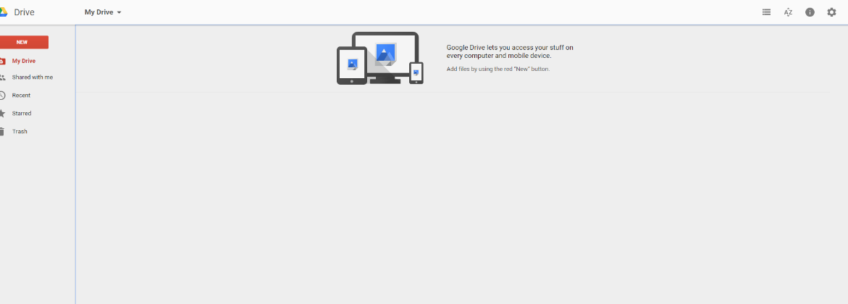

- Click Share with Me on the left menu and your TCHS Portfolio will appear. Double click your name beside the word Portfolio.
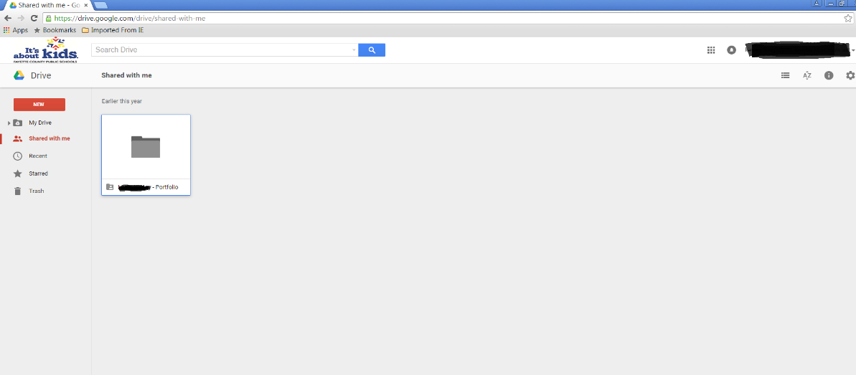
- Select New in the red highlighted menu and drop files in.

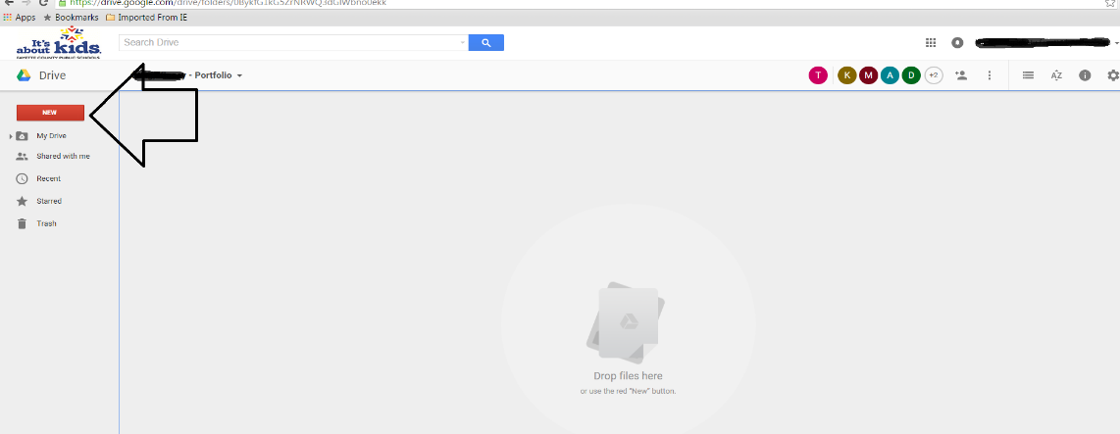

- Your teacher can now see your files Be sure to rename the file whatever your teacher directed you to name it!

